Name
University affiliation
Date
Comparison between Facebook messenger mobile app and web app
There is usually a common misconception that there is no difference between a mobile app and a web app; however, the two are different in many aspects. I will make a comparison between the Facebook mobile app and its web app. It will be important to differentiate between a mobile app and a web app. First of all, a mobile app is build for a platform that is specific in nature. It is downloaded through an app store and run on that particular device. Web app, on the other hand, doesn’t need to be downloaded but is accessed through the internet browser.
The Facebook messenger mobile app is more convenient, the reason why it's more popular than the web app. It also provides a better user experience, and its speed is faster when loading of contents and even easier when using. Unlike the Facebook web app, it has push notifications, with it, you can get updates and reminders on your mobile device. It is also designed in a way that it can fit the screen of your device elegantly when compared to web app version.
The Facebook mobile app allows its users to set preferences, creation of personal accounts as well as the keeping of important information at hand. Another advantage of using the mobile app is that it can be used even when one is offline. Since the apps are directly installed on one's device, you can comfortably access its contents and features without the internet connection. However, the mobile app has its challenges. 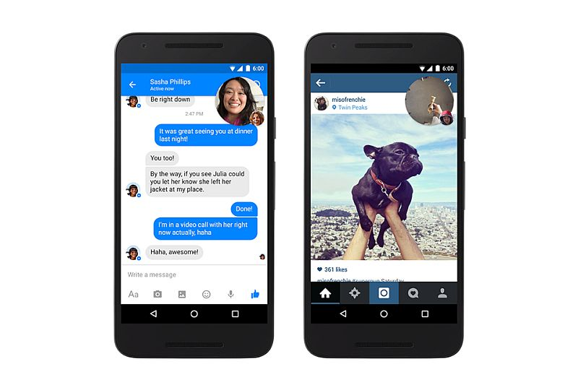
Mobile messenger app
The mobile app may not be compatible with other devices that use different operating devices. This is to mean that every device that uses Windows, Android or iOS requires a separate version of the Facebook messenger app. Therefore, they should be able to come up with a cross-platform solution which can possibly fit on all devices and operating systems. Despite a few disadvantages associated with the Facebook Messenger mobile app, I prefer it because it offers faster access to contents as well as smoother interaction than the web app.
Facebook messenger web app is more compatible because it enhances the user experience when using different types of devices. When you own devices of different types, you can appreciate the compatibility and the responsiveness of the web app. The web app also has a broader reach when compared to the mobile app. This is possible because any user can use different devices to access the same version of the web app hence that makes it win in-terms of usage by many clients.

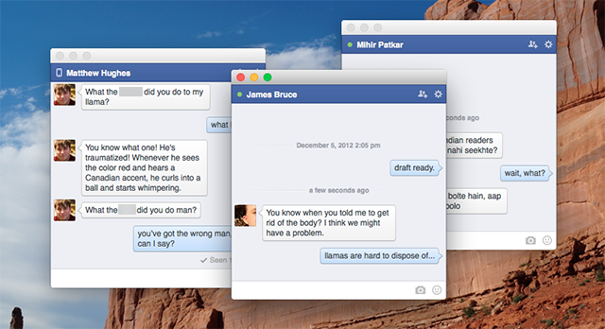
Messenger desktop version
The Facebook messenger web app cost less in terms of upgrading when compared to the mobile app. This is because all you need is to maintain a single version even when it gets updated. Mobile apps, on the other hand, require one to download another version when the app is updated. The messenger web app has its disadvantages too. It does not have a good user experience because it has a single window restriction. The web app cannot work offline and it it does, then it has very limited functionality as it only uses cached pages. Therefore, they should try to develop a web app that does not limit the users' experience.

Screenshot comparison between Facebook messenger mobile app and web app

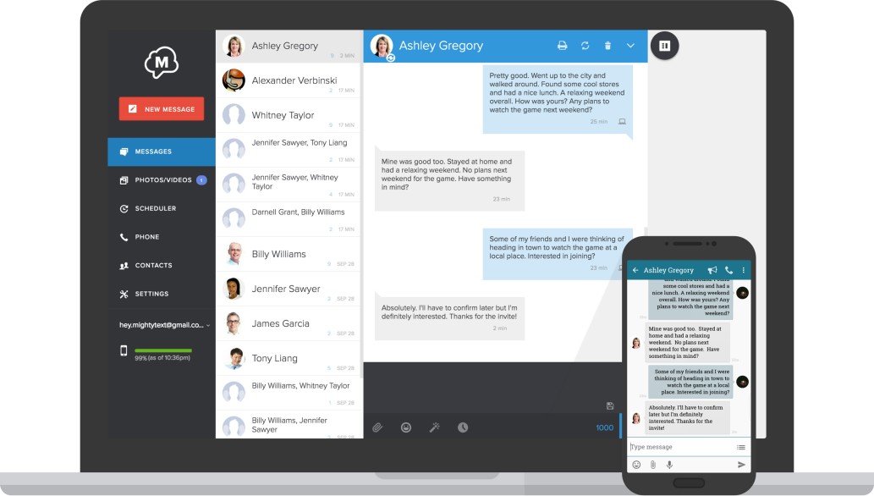

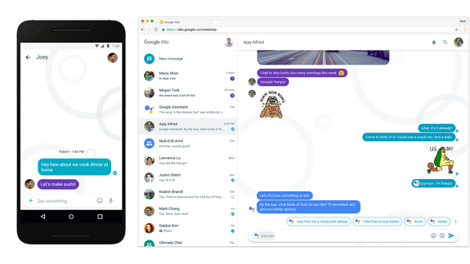

Reference
Karagiannis, Vasileios, Periklis Chatzimisios, Francisco Vazquez-Gallego, and Jesus Alonso-Zarate. "A survey on application layer protocols for the internet of things." Transaction on IoT and Cloud Computing 3, no. 1 (2015): 11-17.

